Merry Christmas
And
Happy New Year!!
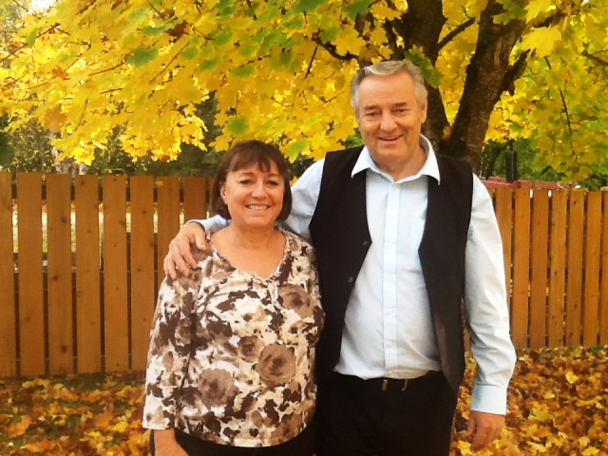
Thank you for your love and support throughout the past year. Our love and prayers go out to all of you. We hope you have a very Merry Christmas and a blessed New Year.
Our love and prayers, Greg and Sandy Lemky

